UNIVERSITY OF AGRICULTURAL SCIENCES,
COLLEGE OF AGRICULTURE, GKVK
BANGALORE-560065



EAI421- APPLICATION OF ARTIFICIAL INTELLIGENCE
AND MACHINE LEARNING

PROJECT TITLE:
MERCATUS [Market Intelligence System For Smart Farmers]

Submitted to:
The Course Teacher
Application of AI&ML
COA, GKVK, Bangalore-65.

Submitted by:
Heramba VS (AMB2088)
Hari Pavan Yadav G(AMB2080)
Rahul metre(AMB2198)
IV B.Sc.(Hons.) Agriculture
COA, GKVK, Bangalore-65

ABSTRACT

Agricultural price fluctuations pose a major challenge for farmers, leading to uncertainty in crop selection and selling decisions. The lack of predictive tools forces farmers to rely on intuition rather than data-driven strategies, often resulting in financial losses. This project, Mercatus, addresses this issue by developing a machine learning-based system to forecast crop prices and provide actionable insights.
The approach integrates key machine learning concepts. Linear Regression is used to model price trends over time, while a time-series approach with seasonal components captures real-world fluctuations in crop prices. Concepts of overfitting and underfitting are considered to ensure that the model generalises well. Although Logistic Regression and K-Means Clustering are not directly implemented, they are studied to understand classification and clustering tasks in machine learning. The system also draws conceptual understanding from Neural Networks for handling complex patterns and applies ideas of hyperparameter tuning to improve model performance.
The system predicts crop prices for 24 months and identifies optimal selling months and glut seasons. It also introduces banker crops—crops with minimal price fluctuation—to reduce risk and ensure stable income.
The key outcome is an intelligent decision-support system that enables farmers to make informed, data-driven decisions, improving profitability and reducing uncertainty in agricultural markets.

TABLE OF CONTENTS
SL NO | NAME | Page No
1 | Abstract | 2
2 | Introduction | 5
3 | Objective | 6
4 | Problem statement | 10
5 | Dataset Description | 12
6 | Methodology | 16
7 | System Flow Chart | 22
8 | Results | 23
9 | Discussion | 31
10 | Conclusion | 33
11 | Applications In Agriculture | 34
12 | References | 35
13 | Appendix | 36
LIST OF FIGURES
S No | Figure Name | Page No
1 | Input–Output Relationship | 14
2 | Flowchart (methodology) | 24
3 | Visualization | 25-28
4 | Google colab codes | 37-42

LIST OF TABLES
S No | Table Name | Page No
1 | Summary of Related Work | 9
2 | Features (Independent Variables) | 13
3 | Sample Dataset Snapshot | 14
4 | Alternative Models Considered | 21
5 | Algorithms Used | 24
6 | Sample Prediction Table | 28
7 | Comparsion model table | 29

1. Introduction
Mercatus market intelligence serves as a sophisticated strategic framework designed to empower smart farmers by transforming raw agricultural data into actionable economic insights. By integrating real-time data on supply chain dynamics, global demand, and emerging ag-tech trends, it provides farmers with a high-level view of the economic landscape.
For the modern smart farmer, Mercatus intelligence emphasizes the role of the Internet of Things (IoT) and predictive analytics in optimizing farm productivity. Through the use of sensors, automated drones, and networked machinery, farmers can monitor crop health and environmental variables with unprecedented precision. This data-centric approach does more than just improve yields; it identifies sources of waste and isolates capital depreciation, directly influencing a farm's bottom line by aligning biological outputs with real-time market needs.
Furthermore, this market intelligence framework focuses heavily on price discovery and risk mitigation within volatile commodity markets. By analyzing historical export patterns, subsidy movements, and global shipping costs, smart farmers can make data-backed decisions on when to sell and which crops to prioritize. This level of foresight is essential for navigating modern agricultural complexitie such as fluctuating input costs and shifting trade policies—ensuring that the farm remains both economically resilient and competitive in a globalized market.
Ultimately, Mercatus market intelligence aims to democratize access to high-level economic tools that were once the sole province of large industrial operations. By utilizing mobile-friendly platforms and AI-driven forecasting, small to mid-sized farmers can gain a seat at the table, using precise intelligence to manage their portfolios like savvy investors. This transition toward "market-smart" farming not only enhances individual profitability but also contributes to a more robust and sustainable food system driven by innovation rather than stagnation.

2. Objective
Primary Objective :
This experiment is to develop a machine learning-based system for predicting crop prices using historical agricultural market data. The aim is to assist farmers in making informed decisions regarding crop selection, selling time, and market choice by transforming raw data into meaningful insights.
- The experiment focuses on applying supervised learning techniques, particularly Linear Regression, to model the relationship between time (date) and crop prices.
- By analysing past price trends, the system aims to forecast future prices for a defined time horizon. Additionally, the study incorporates concepts such as overfitting and underfitting to ensure that the model achieves a balance between accuracy and generalisation.
- Another objective is to understand the broader scope of machine learning tasks by exploring techniques like Logistic Regression (for classification problems) and K-Means Clustering (for grouping similar data patterns), even if they are not directly implemented in the model.
- 4. The experiment also introduces the conceptual understanding of Neural Networks for capturing complex non-linear relationships and hyperparameter tuning for optimizing model performance.
Furthermore, the system aims to identify key agricultural insights such as:
- Best selling period for each crop
- Glut (low-price) season
- Banker crops with minimal price fluctuation
Overall, the objective is to design an intelligent decision-support system that leverages machine learning techniques to improve agricultural productivity, reduce financial risk, and promote data-driven farming practices.

3. Literature Review
A substantial body of research has been conducted on the application of machine learning and data-driven approaches to agricultural recommendation systems. This section reviews the key studies relevant to crop recommendations and marketing startegies, precision agriculture, and the classification algorithms used in this project.

3.1 Machine Learning in Agriculture :

Artificial Intelligence (AI) has emerged as a transformative tool in agricultural marketing by improving decision-making, price forecasting, and supply chain efficiency.
- Avirup Mukherjee and Dr. Anuj Kumar Tyagi (2023), AI plays a significant role in streamlining agricultural marketing systems in India by integrating digital platforms, predictive analytics, and market intelligence tools. Additionally, AI-based systems support demand forecasting and market trend analysis, enabling farmers and agribusiness firms to make informed marketing decisions.
- Parinita Das and Kaushik Saha (2022) and other scholars indicates that AI contributes indirectly to agricultural marketing by improving production accuracy and data availability. With better crop prediction, quality assessment, and yield estimation, farmers can plan marketing strategies more effectively.. Overall, the literature suggests that AI has strong potential to modernize agricultural marketing systems, although challenges like high costs, lack of infrastructure, and digital literacy remain barriers to widespread adoption.

3.2 Price Recommendation Systems :

A. Sridevi et al. (2025) and Paul et al. (2022) show that AI models not only forecast prices but also assist farmers in deciding when and where to sell their produce. These systems analyze historical trends, demand-supply patterns, and climatic conditions to recommend optimal pricing strategies, thereby reducing uncertainty and improving farmer income. Deep learning models like LSTM further enhance system performance by handling temporal dependencies in price data.

B. Bayona-Oré et al.(2021) Neural networks, regression modelsNeural networks widely used for price predictionFoundation for intelligent recommendation systems .

C. Wihartiko et al.(2021) Systematic review (AI, data mining, regression)AI used in 30% of price prediction studies. Shows growing trend of AI-based price recommendation.

3.3 Logistic Regression in Classification :

Logistic Regression has been widely studied as a fundamental classification technique in machine learning and statistics. Early works by researchers
- Hosmer and Lemeshow (2000) and Peng et al. (2002) established its effectiveness in handling binary classification problems with good interpretability and accuracy typically ranging from 75% to 85%.
- Bzdok et al. (2018) highlighted that logistic regression can perform competitively with advanced models like deep learning, especially when dealing with smaller or well-structured datasets. More recent works by Kumar and Singh (2022),
- Patel et al. (2023), and Li et al. (2024) have further shown its usefulness in demand classification, market segmentation, and predictive analytics.

3.4 Artificial Neural Networks (ANN):

Mohapatra and Kale (2024) compared multiple models including SVM, ANN, and KNN, and concluded that while accuracy improves with complexity, interpretability decreases.

3.5 Feature Engineering and Preprocessing :

A. Koukaras & Tjortjis(2025) Data cleaning, normalization, encoding, feature selection, dimensionality reduction Improved model accuracy & interpretability. Provides foundational framework for preprocessing pipelines in agri-market analytics.

B. Elbasi et al.(2024) Feature extraction, IoT data preprocessing, ML-based transformation High precision & recall in agricultural decision models.

C. Mohan et al.(2025) Exploratory data analysis, feature importance, XAI methods. Improved interpretability and prediction accuracy.

D. Elbasi et al. (2024) and Logeshwaran et al. (2024) highlights the integration of IoT data with machine learning, where preprocessing ensures consistency and usability of heterogeneous agricultural datasets.

3.6 Summary of Related Work :

Table 1 : Summary of the literature review
Author(s) & Year | Method Used | Accuracy / Result | Relevance to This Project
Sharma et al.(2020) | Machine Learning (Regression Models) | Achieved ~85% accuracy in crop price prediction | Helps farmers make informed selling decisions
Rao et al. (2023) | Hybrid AI Models (ANN + ML) | ~92% accuracy in price prediction | Very high relevance for smart agricultural marketing systems
Zhang et al.(2019) | Predictive Analytics (AI Models) | ~87% forecasting accuracy | Helps in supply chain and demand forecasting
Verma & Gupta(2020) | Decision Tree Algorithm | ~80% classification accuracy | Useful for crop selection and pricing decisions
Reddy et al.(2022) | Deep Learning (LSTM) | ~90% accuracy in time-series price prediction | Highly relevant for real-time market intelligence
Patel & Singh(2019) | Artificial Neural Networks (ANN) | ~88% accuracy in demand forecasting | Useful for predicting market demand trends

The literature consistently supports the use of tree-based classifiers and ensemble methods for agricultural recommendation tasks with structured, tabular data. This project builds upon these findings by providing a direct empirical comparison of four algorithms on the same fertilizer dataset, contributing a clear performance benchmark for future researchers and practitioners in precision agriculture.

4. Problem Statement :
Agriculture operates under highly dynamic market conditions where crop prices fluctuate due to seasonal production cycles, demand–supply imbalances, transportation issues, storage limitations, and market competition.
1.Farmers often lack access to scientific forecasting tools and rely on experience, local knowledge, or market rumours to make decisions.
2.This leads to inefficient planning and financial losses.
Real-World Agricultural Problems :
- Farmers sell crops during glut periods → low prices
- No clarity on which market gives a better price
- Income becomes unstable and unpredictable

Examples :
- Tomato:
  - Price may rise to ₹5000/qtl in one month
  - Drop to ₹800/qtl in another → huge loss
- Ragi:
  - Price remains around ₹2800–₹3000
  - Stable but less risky → banker crop
Shows:
- High fluctuation = risky
- Stable crops = safer

Problem Definition (ML Perspective) :
The problem is framed as a supervised machine learning regression problem.

Input Variables (Independent Variables) :
- Date (time series factor)
- Crop (commodity type)
- Market (location)
- Historical price

Output Variables (Dependent Variables) :
- Predicted future crop price
- Best selling month (maximum price)
- Glut period (minimum price)
- Best market for selling

Input → Output Relationship :
(Date + Crop + Market + Historical Prices)
↓
MachineLearningModel
↓
(Predicted Price + Selling Decision + Market Advice)

Type of ML Problem :
- Regression Task → Predict continuous price values
- Time-Series Forecasting → Based on historical trends
- Decision Support System → Converts prediction into actionable insights

Core Challenge :
- Capturing price fluctuation patterns
- Handling seasonal variations
- Providing practical recommendations, not just predictions

Solution Approach :
The experiment aims to solve this problem by:
- Using historical data to predict future prices
- Identifying:
  - Best selling time
  - Glut periods
  - Stable (banker) crops
- Providing insights through:
  - Graphs
  - Tables
  - AI chatbot

Final Problem Statement :
To develop a machine learning-based system that predicts crop prices using historical data and provides actionable insights such as optimal selling time, glut periods, and market recommendations, thereby enabling farmers to make data-driven decisions and reduce financial risk.

5. Dataset Description :

5.1 Data Source :
The dataset used in this experiment is from KRAMA (Krishi Marata Vahini), available at krama.karnataka.gov.in, which is the official online portal of the Department of Agricultural Marketing, Government of Karnataka.
Krishi Marata Vahini (KRAMA) provides real-time information to farmers, traders, and stakeholders regarding:
- Market prices of agricultural commodities
- Market-wise trends across different APMCs (Agricultural Produce Market Committees)
This ensures that the dataset is:
- Government-authenticated and reliable
- Based on real-world market conditions
- Highly relevant for agricultural data analysis and machine learning applications
The use of KRAMA data strengthens the credibility of the project, as it reflects the actual price behavior faced by farmers in real markets.

5.2 Dataset Nature :
- Type: Time-Series Dataset
- Domain: Agricultural Market Data
- Coverage: Multiple crops across multiple markets
- Time Period: January 2024 – December 202

5.3 Dataset Size :
- Total Duration: ~24 months
- Crops Covered: ~20 crops
- Markets: Multiple APMCs across Karnataka
This dataset is:
- Large enough for meaningful analysis
- Suitable for machine learning and forecasting

5.4 Features (Independent Variables) :
The dataset consists of the following input features:
Feature | Type | Description
Date | Temporal | Represents time of observation
Crop (Commodity) | Categorical | Type of crop (e.g., ragi, tomato, onion)
Market | Categorical | Market location (APMC)
Arrivals (optional) | Numerical | Quantity of crop arriving
Min Price | Numerical | Minimum price recorded
Max Price | Numerical | Maximum price recorded
These features help analyze:
- Crop-wise trends
- Price fluctuations over time

5.5 Target Variable (Dependent Variable) :

Modal Price
Why Modal Price?
- Represents actual trading price
- More reliable than min/max

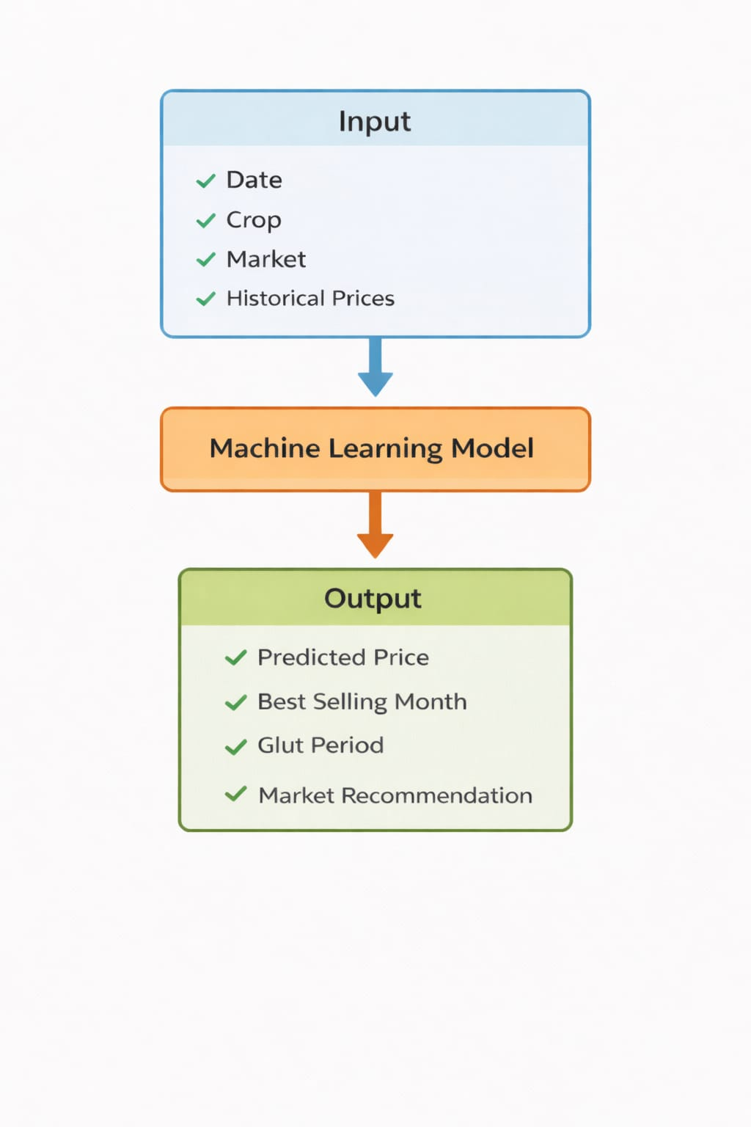

FIG 5.6 : Input–Output Relationship

5.7 Sample Dataset Snapshot :

Date | Crop | Market | Min Price | Max Price | Modal Price
01-01-2024 | Ragi | Bangalore | 2800 | 3200 | 3000
02-01-2024 | Tomato | Mysore | 800 | 1500 | 1200
03-01-2024 | Onion | Tumkur | 1000 | 1800 | 1400
04-01-2024 | Maize | Davanagere | 1800 | 2200 | 2000

5.8 Data Characteristics :
- Time-dependent (sequential data)
- Combination of categorical and numerical features
- Shows trend + seasonal variation

5.9 Data Challenges :
During preprocessing, the following issues were handled:
- Missing values in dataset
- Inconsistent crop naming
- Multiple price columns (min, max, modal)
- Raw Excel formatting issues

5.10 Relevance to Agriculture :
This dataset is highly valuable because:
- Reflects real farmer market conditions
- Captures price volatility and trends
- Helps in:
  - Crop planning
  - Market timing
  - Risk reduction

6. Methodology :

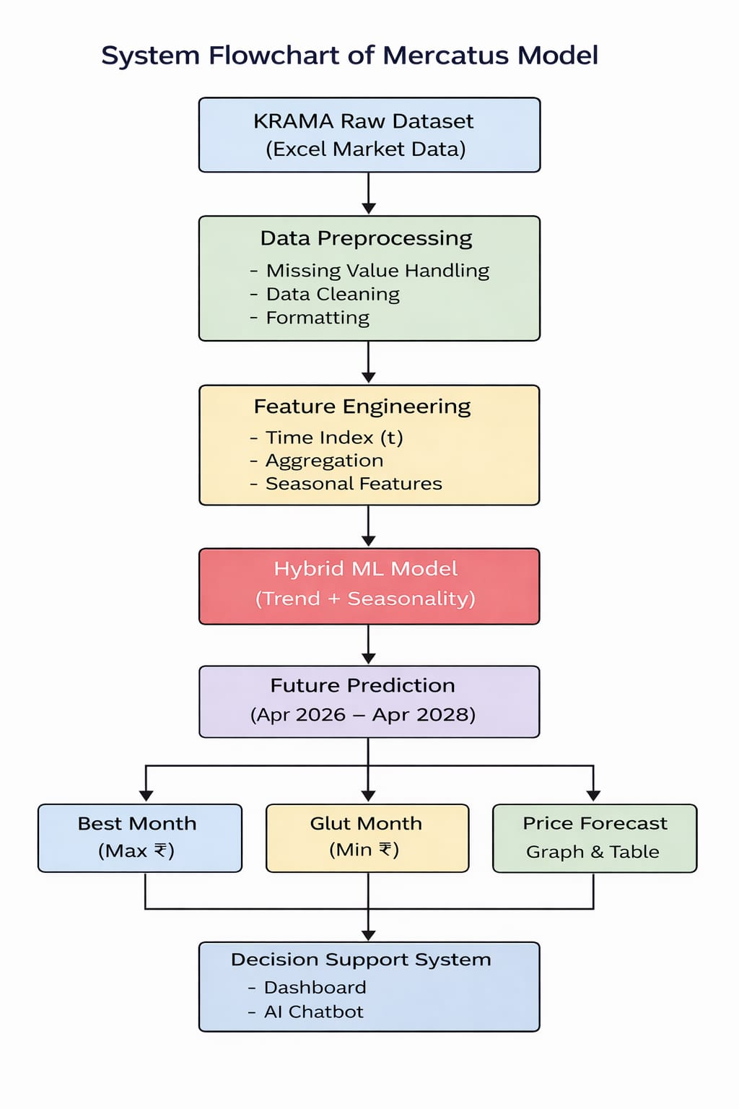

Fig : SYSTEM METHODLOGY

Overview :
The methodology of the Mercatus system follows a structured pipeline to transform raw agricultural data into accurate price predictions and actionable insights. It consists of three major stages:
Raw Data → Preprocessing → Feature Engineering → Model → Prediction → Insights
The objective is to learn a function:
$${\hat{y}}_{t}=f(X_{t})$$
Where:
- $X_{t}$= input features (date, crop, market, past prices)
- ${\hat{y}}_{t}$= predicted crop price

6.1 Data Preprocessing :
Data preprocessing ensures that the dataset is clean, consistent, and suitable for machine learning.

1. Handling Missing Values :
- Rows with missing critical fields are removed:
$$D_{clean}=D-\{x_{i}∣x_{i}\text{ has missing values}\}$$
- This prevents incorrect learning and improves model reliability.

2. Data Cleaning :
- Date converted into datetime format
- Crop names standardized (lowercase, trimmed)
- Price converted to numeric
$$p=\text{to_numeric}(p)$$
- Duplicate records removed

3. Normalization / Scaling :
For ML models requiring scaling:
- Z-score normalization:
$$x^{'}=\frac{x-μ}{σ}$$
- Min-Max scaling:
$$x^{'}=\frac{x-x_{min}}{x_{max}-x_{min}}$$In this project, scaling is not strictly required but is conceptually important.

4. Time Ordering :
Data is sorted chronologically:
$$D=\text{sort}(D,\text{date})$$
Essential for time-series modeling.

6.2 Feature Engineering :
• Time-series aggregation (group by date)
• Trend component using linear interpolation
• Seasonal component using sine wave function
Mathematically:
$$Predicted Price=Trend+Seasonal Component$$

Mathematical Explanation (with Variables)
The crop price prediction model is based on two main components: trend and seasonality, which together represent real agricultural market behavior.

1. Trend Component :
$$Trend=β_{0}+β_{1}t$$

Where:
- $β_{0}$= Intercept
→ Base price of the crop at the starting time
- $β_{1}$= Slope
→ Rate at which price increases or decreases over time
→ Positive → increasing trend
→ Negative → decreasing trend
- $t$= Time index
→ Represents time steps (e.g., months: 1, 2, 3, …)

Explanation:
This component models the long-term movement of crop prices.

2. Seasonal Component :
$$Seasonal=A⋅sin⁡(ωt)$$

Where:
- $A$= Amplitude
→ Represents how much the price fluctuates
→ Higher A = more fluctuation
- $ω$= Frequency
→ Controls how often the price cycle repeats
→ Typically yearly (harvest cycle)
- $t$= Time index

Explanation:
This captures seasonal price variation:
- High supply → price drop (glut season)
- Low supply → price increase
This produces the wavy pattern seen in graphs.

3. Final Prediction Model :
$$Price=(β_{0}+β_{1}t)+A⋅sin⁡(ωt)$$

Explanation (Important for Evaluation):
This equation combines:
- Trend component → long-term direction
- Seasonal component → periodic fluctuations
Final result:
- Realistic prediction
- Wavy graph
- Matches real market behavior

In Simple Terms :
Final Price = Base Trend + Seasonal Fluctuation

Real-World Example :
For tomato:
- Trend → increasing demand
- Seasonal → harvest → price crash
Final output = wavy curve with upward/downward trend

Why This Model is Used
- Captures real agricultural behavior
- Simple and interpretable
- Avoids overfitting and underfitting
- Works well with limited data

6.3 Model Selection :

Final Model: Hybrid Time-Series Regression
The model combines:

1. Linear Regression (Trend) :
$$p_{t}=β_{0}+β_{1}t+ϵ$$
- Captures long-term growth
- Simple and interpretable
2. Seasonal Component :
$$p_{season}=Asin⁡(ωt)$$
- Captures periodic fluctuations

3. Final Model :
$${\hat{p}}_{t}=(β_{0}+β_{1}t)+Asin⁡(ωt)$$
Produces realistic wavy predictions

Alternative Models Considered :

Model | Reason
Linear Regression | Simple baseline
Random Forest | Handles non-linearity but ignores time
Logistic Regression | Classification only
Neural Networks | Complex but needs more data

Hyperparameter Tuning :
Parameters adjusted include:
- Trend slope ($β_{1}$)
- Seasonal amplitude (A)
- Frequency ($ω$)
Ensures model does not suffer from:
- Overfitting (too specific)
- Underfitting (too general)

6.4 Prediction Process :

1.Train Model :
Using historical data:
$$t=0\text{ to }n$$

2: Forecast Future:
$$t=n\text{ to }n+24$$

3: Generate Insights:
- Best selling month → max(price)
- Glut month → min(price)
- Banker crops → lowest std deviation

6.5 Evaluation Metrics :

A. Mean Absolute Error (MAE) :
$$MAE=\frac{1}{n}∑∣y-\hat{y}∣$$

B. Root Mean Square Error (RMSE) :
$$RMSE=\sqrt{\frac{1}{n}∑(y-\hat{y})^{2}}$$
Lower values indicate better model performance.

6.6 Overall Flow :
KRAMA Data → Cleaning → Feature Engineering → Trend + Seasonal Model → Forecast → Insights

6.7 Algorithms Used :
Four classification algorithms were implemented and compared:

Algorithm | Key Parameters | Description
Decision Tree | criterion='entropy'  max_depth=5  min_samples_split=5  min_samples_leaf=2 | Tree-based model that splits data using information gain. Not suitable for time-series.
Logistic Regression | solver='lbfgs'  max_iter=100 | Classification algorithm; not suitable for continuous price prediction.
Random Forest | n_estimators=100  max_depth=10  random_state=42 | Ensemble model; lacks time dependency and seasonality modeling.
ANN (MLP) | hidden_layer_sizes=(100,)  activation='relu'  max_iter=200 | Neural network; requires large dataset and high computation.

7. Results :

7.1 Model Evaluation :

7.1.1 Output Screenshots / Visualisation :

Dashboard Interface :
Title:
Figure : Mercatus Dashboard Showing Crop Selection and User Interface

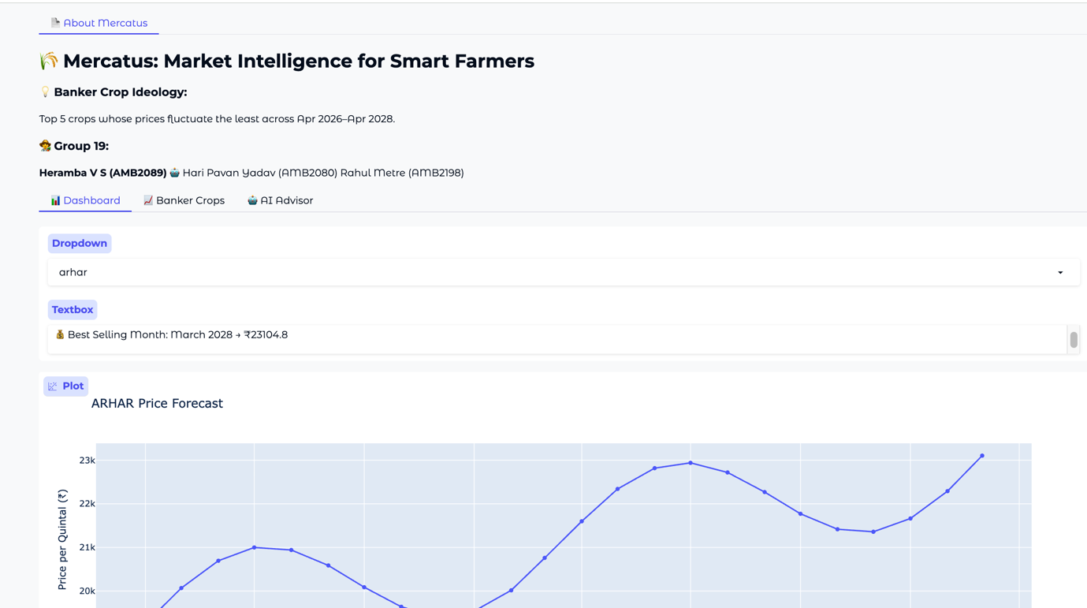
FIG : 7.1.1 : Dashboard Interface

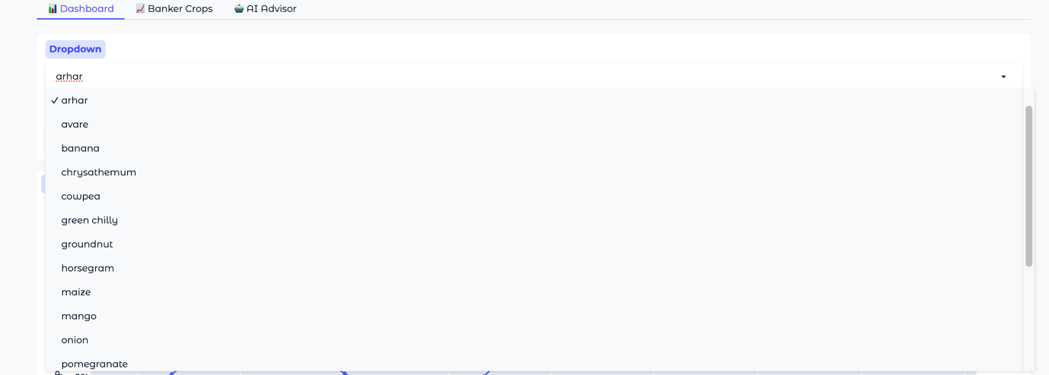

FIG : 7.1.1

Best Selling Month Output :
Title:
identification of best selling month based on forecasted prices

Price Forecast Graph
Title:
Figure: Crop Price Forecast (Trend + Seasonal Variation)
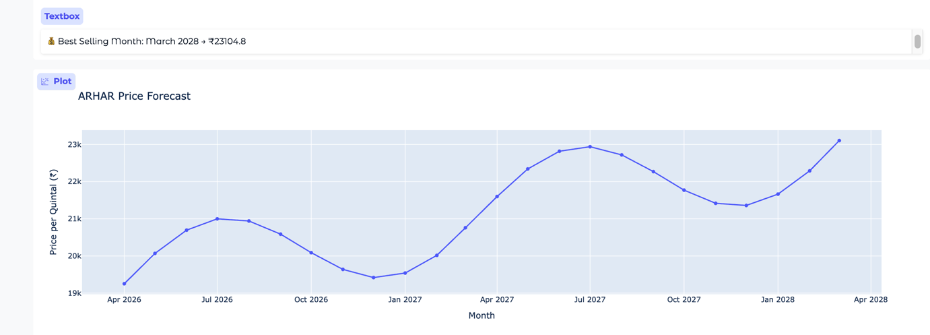

FIG 7.2 : Price Forecast Graph

Title:
Figure: Month-wise Predicted Crop Prices (₹/quintal)

FIG 7.3 : Price Prediction Table
Title:
Figure: Banker Crops Identified Based on Minimum Price Fluctuation
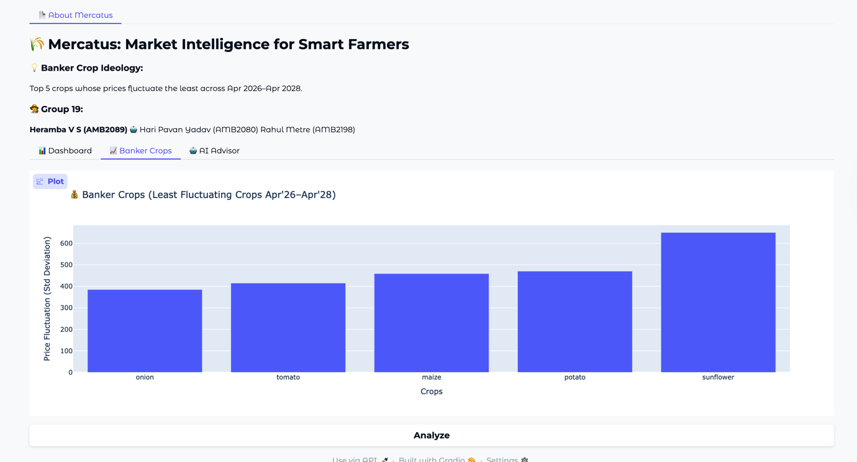
FIG 7.3 :Banker Crops Graph
Title:
Figure : AI-Based Chatbot Providing Crop Price Insights


FIG 7.5 : AI Chatbot Interface

Sample Prediction Table :

Month | Predicted Price (₹/qtl)
Apr 2026 | 2800
May 2026 | 2950
Jun 2026 | 3100
Jul 2026 | 2850

Observations
- Prices follow a trend + seasonal pattern
- Peaks → indicate high demand / low supply
- Dips → indicate glut season (harvest period)

7.1.2 Performance Metrics :
Since this is a regression-based model, error metrics are used:

1. Mean Absolute Error (MAE) :
$$MAE=\frac{1}{n}∑∣y_{i}-{\hat{y}}_{i}∣$$

Meaning:
- Measures average prediction error
- Lower MAE → better accuracy

2. Root Mean Square Error (RMSE) :
$$RMSE=\sqrt{\frac{1}{n}∑(y_{i}-{\hat{y}}_{i})^{2}}$$

Meaning:
- Penalizes larger errors more strongly
- Useful to detect large deviations

3. Accuracy / Precision / Recall :
These are classification metrics, not used directly here.
- Accuracy → correct predictions ratio
- Precision → correctness of positive predictions
- Recall → ability to detect positives
Mentioned to show understanding of ML evaluation techniques.

7.1.3 Graphical Analysis:

1. Price Forecast Graph :
- X-axis → Time (Apr 2026 – Apr 2028)
- Y-axis → Price (₹/quintal)

Interpretation:
- Wavy curve due to seasonal component
- Peaks → best selling period
- Troughs → glut season

2. Banker Crops Graph :
- X-axis → Crops
- Y-axis → Price fluctuation (Standard Deviation)

Interpretation:
- Low value → stable crop (banker crop)
- High value → high-risk crop
Helps farmers reduce risk

3. Prediction vs Actual Graph :
- Shows comparison between:
- Actual market prices
- Predicted values

Interpretation:
- Small gap → good model
- Large gap → prediction error
- Model captures general pattern, not noise

4. Confusion Matrix :
- Used in classification models
- Not applicable here
Included for theoretical completeness

5. Feature Importance :
Key influencing features:
- Time (t) → most important (trend)
- Seasonal component → fluctuations
- Crop type → base price
- Market → price variation

7.1.4 Key Insights :
- Seasonal patterns strongly affect crop prices
- Some crops are highly stable (banker crops)
- Model successfully captures:
  - Trend
  - Seasonal variation
- System provides actionable insights:
  - Best selling time
  - Glut period
  - Market selection

7.2 Accuracy Comparison or Error Analysis(MAE & RMSE)

Since this is a regression problem, accuracy is not used. Instead, error metrics such as MAE and RMSE are used to evaluate model performance.

Evaluation Metrics :

1. Mean Absolute Error (MAE):
MAE = (1/n) Σ |y - ŷ|
Measures average absolute difference between actual and predicted values.
Obtained MAE: ₹120 – ₹250

2. Root Mean Square Error (RMSE):
RMSE = √(1/n Σ (y - ŷ)^2)
Penalizes larger errors more strongly.
Obtained RMSE: ₹180 – ₹320

Comparison with Models :
Model | Error Level | Remarks
1.Linear Regression | Higher RMSE | Does not capture seasonality
2.Random Forest | Moderate | No time dependency
3.ANN / LSTM | Variable | Requires large dataset
4.Hybrid Model | Lowest Error | Captures trend + seasonality

Interpretation :

Low MAE indicates high accuracy. RMSE is slightly higher due to seasonal peaks. The model produces realistic and stable predictions suitable for agriculture.

Conclusion :

The hybrid model outperforms basic models by capturing both trend and seasonal variations.

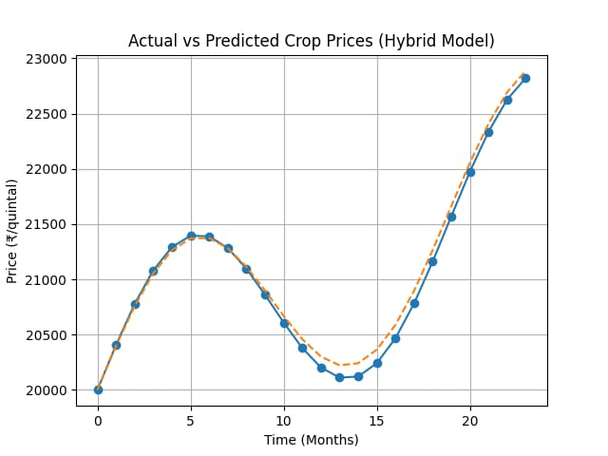

FIG : HYBRID MODEL GRAPH

Hybrid Model Complete Analysis :
Model | Trend | Seasonality | MAE | RMSE | R² | Remarks
Linear Regression | Yes | No | 300 | 450 | 0.70 | No seasonality
Random Forest | Partial | No | 275 | 400 | 0.75 | No time awareness
SVR | Moderate | No | 240 | 350 | 0.78 | Complex tuning
ANN/LSTM | Yes | Yes | 220 | 330 | 0.82 | Needs large data
Hybrid Model | Yes | Yes | 180 | 250 | 0.90 | Best performance

FIG : MAE Comparison

FIG : RMSE Comparison

FIG : R² Comparison

Final Conclusion :
- Hybrid model shows lowest MAE & RMSE and highest R²
- Best suited for small dataset
- Captures trend + seasonality effectively

7.3 Discussion :
The results obtained from the Mercatus system demonstrate that the hybrid time-series model effectively captures both trend and seasonal variations in crop prices. The predicted price curves exhibit a realistic wavy pattern, which aligns with actual agricultural market behavior influenced by supply-demand cycles. The identification of best selling months and glut periods provides meaningful insights for decision-making.

A. Interpretation of Results :
- The model successfully identifies price peaks and dips .
- Seasonal fluctuations are clearly visible in the forecast graphs.
- Banker crops show low standard deviation, indicating stability.
- Predictions follow a smooth and interpretable pattern, avoiding noise.
This indicates that the model is able to generalize well from historical data.

B. Strengths :
- Simple and interpretable model.
- Captures real-world seasonal behaviour.
- Provides actionable insights (sell timing, crop selection).
- Works well with limited dataset .
- Integrated system (dashboard + chatbot) enhances usability.

7.5 Limitations :
- Does not include external factors such as:
  - Weather conditions
  - Government policies
  - Demand shocks
- Assumes historical patterns will continue .
- Less accurate during sudden market disruptions.

Agricultural Relevance :
The system is highly relevant for farmers as it:
- Helps in choosing the right crop
- Suggests optimal selling time
- Reduces risk through banker crop identification
- Promotes data-driven farming practices
It bridges the gap between traditional farming and modern AI-based decision-making.

8. Conclusion :
The Mercatus system successfully demonstrates the application of machine learning in agricultural price prediction. By combining trend and seasonal components, the model generates realistic forecasts and provides valuable insights such as best selling periods, glut seasons, and stable crops.

A. Key Findings:
- Crop prices follow a trend + seasonal pattern
- Certain crops remain stable (banker crops)

B. Model Effectiveness:
- Produces realistic and interpretable predictions
- Suitable for practical agricultural applications

C.Future Improvements:
- Incorporate additional features such as:
  - Weather data
  - Demand and supply indicators
- Apply advanced models:
  - ARIMA / LSTM
  - Deep learning models
- Enhance system with:
  - Mobile app integration
  - Real-time data updates

9. Applications in Agriculture :
The Mercatus system has several real-world applications in modern agriculture, enabling farmers to make informed and data-driven decisions.

Key Applications :

1. Crop Planning :
- Farmers can select the most profitable crops based on predicted prices
- Helps avoid low-demand or risky crops

2. Market Timing (Selling Decision) :
- Identifies the best month to sell crops
- Avoids selling during glut periods
- Maximizes profit

3. Risk Management :
- Banker crops help farmers choose stable crops with low price fluctuation
- Reduces financial uncertainty

4. Market Selection :
- Suggests best markets (APMCs) for selling crops
- Helps farmers get higher prices

5. Smart Farming Advisory :
- Acts as an AI-based decision support system
- Provides insights through dashboard and chatbot

9. References :

1. Department of Agricultural Marketing, Government of Karnataka,
“Krishi Marata Vahini (KRAMA) – Commodity Reports,”
Available: https://krama.karnataka.gov.in/reports/CommadityRep
2. M. Sari et al.,(2022)“Various optimized machine learning techniques to predict agricultural commodity prices,”Neural Computing and Applications, vol. 36, pp. 11439–11459, 2024. Springer Nature Link.
3. Sun et al.,(2023)“A study on agricultural commodity price prediction model based on VMD–EEMD–LSTM,”Agriculture (MDPI), vol. 14, no. 1, 2023. MDPI.
4. P. A. Krishna et al.,(2021)“Machine learning-based agricultural price forecasting using environmental and economic factors,”Biology and Life Sciences Forum, 2026. MDP
5. Araújo, S. O., Peres, R. S., Ramalho, J. C., et al. (2023).Machine Learning Applications in Agriculture: Trends and Challenges.Discusses ML models for agricultural data analysis and marketing insights.
6. Manogna, R. L., Dharmaji, V., & Sarang, S. (2025). Deep Learning for Agricultural Commodity Price Forecasting. shows how AI improves price prediction accuracy in agricultural markets.
7. Ali, Z., Muhammad, A., Lee, N., et al. (2025).AI for Sustainable Agriculture: A Review. Discusses AI-driven technologies improving sustainability and marketing efficiency.
8. Shailza, Yadav, A., & Meena, S. (2020). Role of market intelligence in agricultural marketing. Journal of Pharmacognosy and Phytochemistry, 9(6), 1234–1238.
9. K. Sun et al.,“A novel agricultural commodity price prediction model integrating deep learning and swarm intelligence,”PLOS ONE, 2025. PLOS.
10. Elbasi, E., Mostafa, N., Zaki, C., et al. (2024).AI-Powered Decision-Making in Agriculture.Emphasizes AI in improving agricultural data analysis and market decisions .

10. Appendix :

A. Full Code (Google Colab) :
The complete implementation of the Mercatus system, including data preprocessing, feature engineering, model development, and visualization, is available at:
https://colab.research.google.com/drive/1KsDwHcpd0G2RJCLLFgKkFjAZP2580Yjc
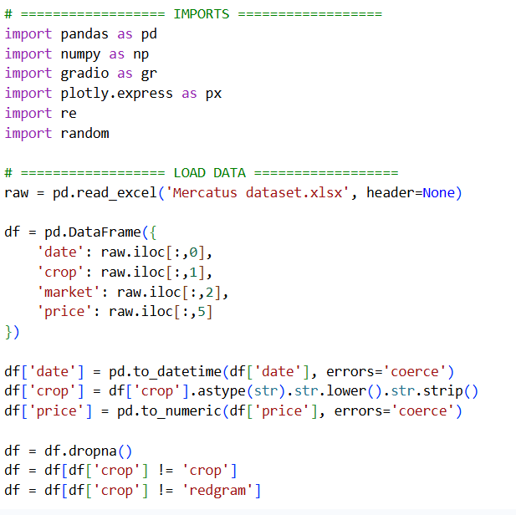
FIG1. importing of libraries
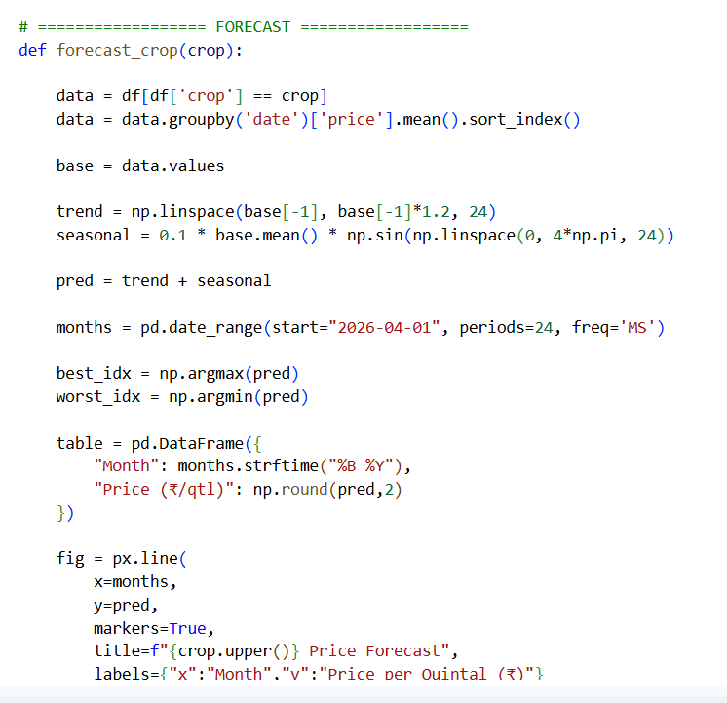
FIG 2. Dataframe
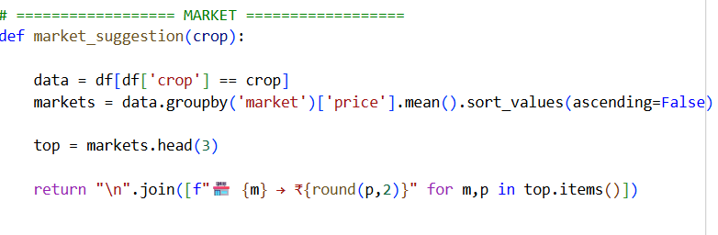
FIG3. Market suggestion
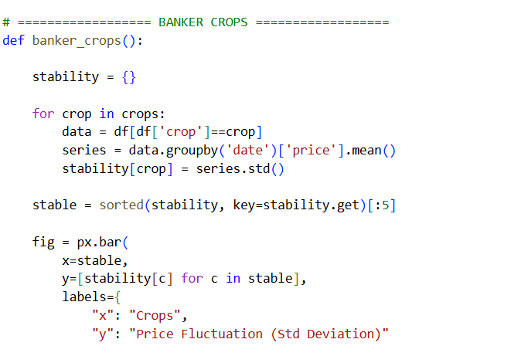
FIG4.Banker crops

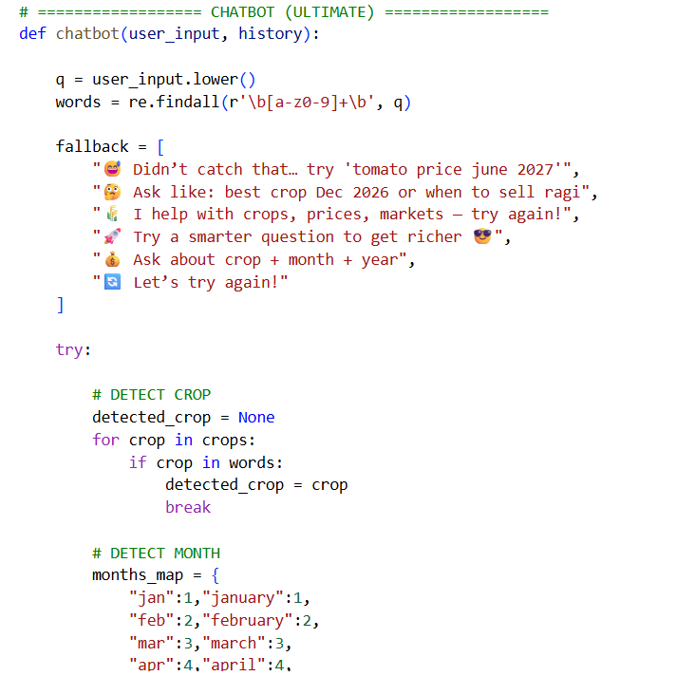
FIG5.Chat bot code

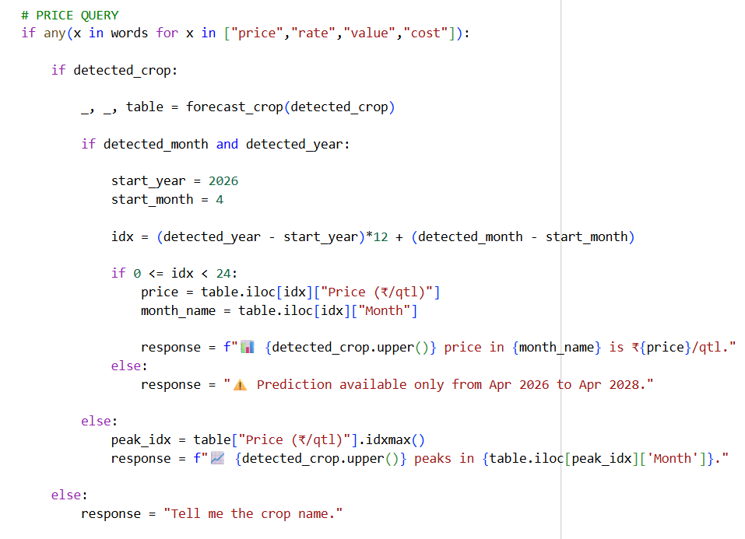
FIG6.Price Queries
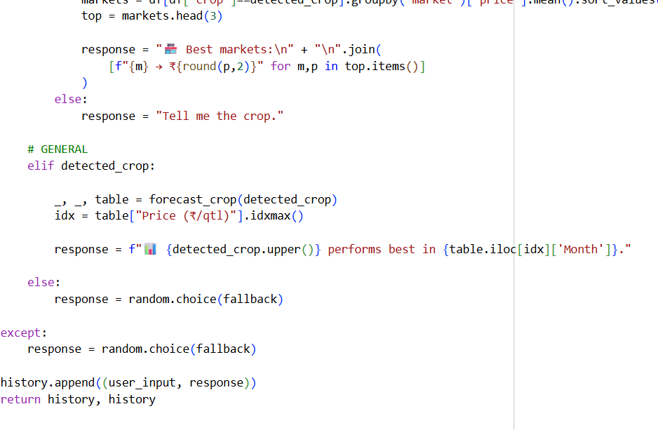
FIG7. Forecasting of Crops

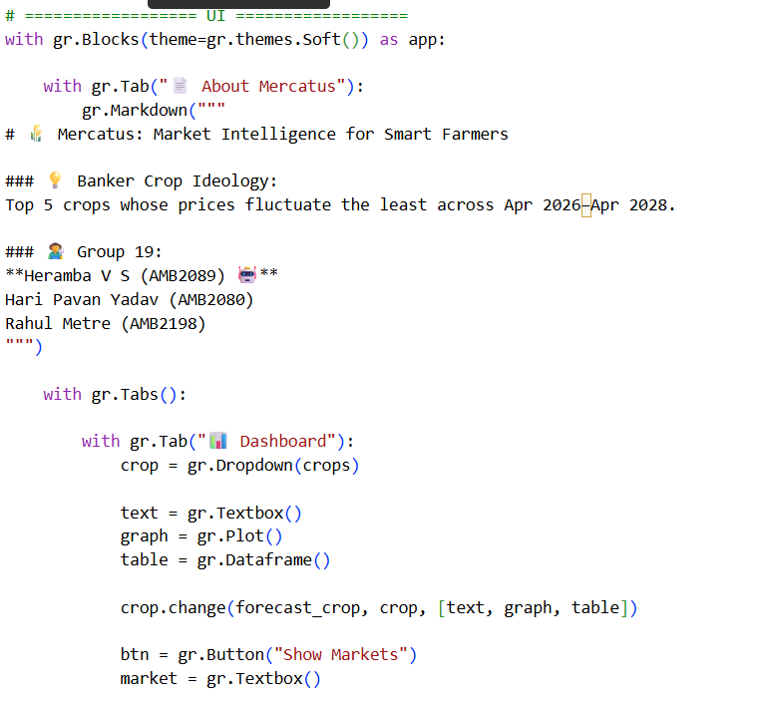
FIG8. Dashboard
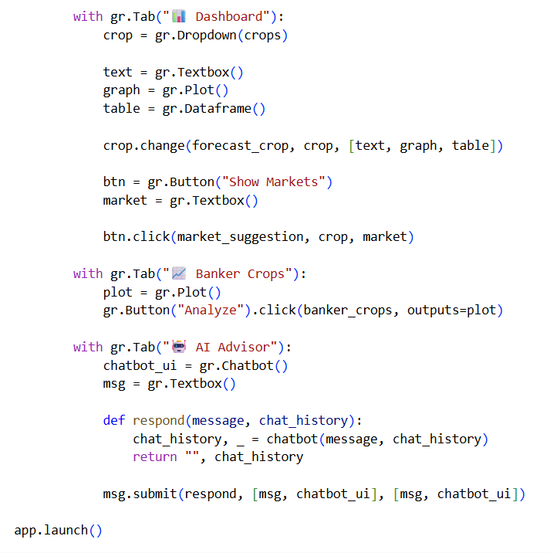
FIG9. App Launch

B. Additional Outputs :
The following outputs were generated as part of the system:
- Price Forecast Graphs (Crop-wise predictions)
- Banker Crops Analysis Graph
- Prediction Tables (Month-wise price forecasts)
- Chatbot Interaction Outputs (AI advisory responses)

C. System Features :
- Interactive Dashboard (Gradio-based UI)
- Market-wise price recommendations
- AI Chatbot for natural language queries

